**CCMP 606 – Orchestration of Cloud Resources  
Assignment 2 Report**

Instructor: **Yongchang He**

Student: **Hai Nam Nguyen – 000520322 – nguyen0465@saskpolytech.ca**

2023/2024 Winter Semester

Saskatchewan Polytechnic

Submitted:

**January 29th, 2024**

1. **Smart Contract Compiled and Deployed**

In the code, file **oracle-node.py**, line 54-75 is a function compile this contract. On line **62**, I have added **solc_version=’0.8.17’** to matched with the version in the **main** function.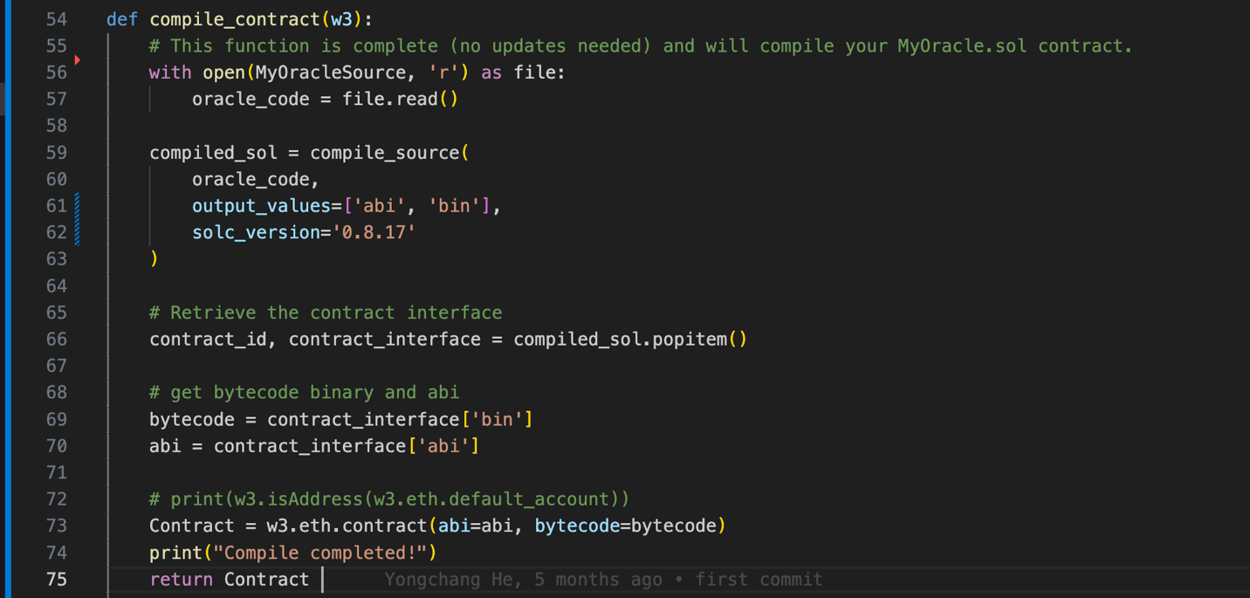

Line **78-99** is the one that use to deploy the contract, I have made some changes to make it work, such as added **‘nonce’**.

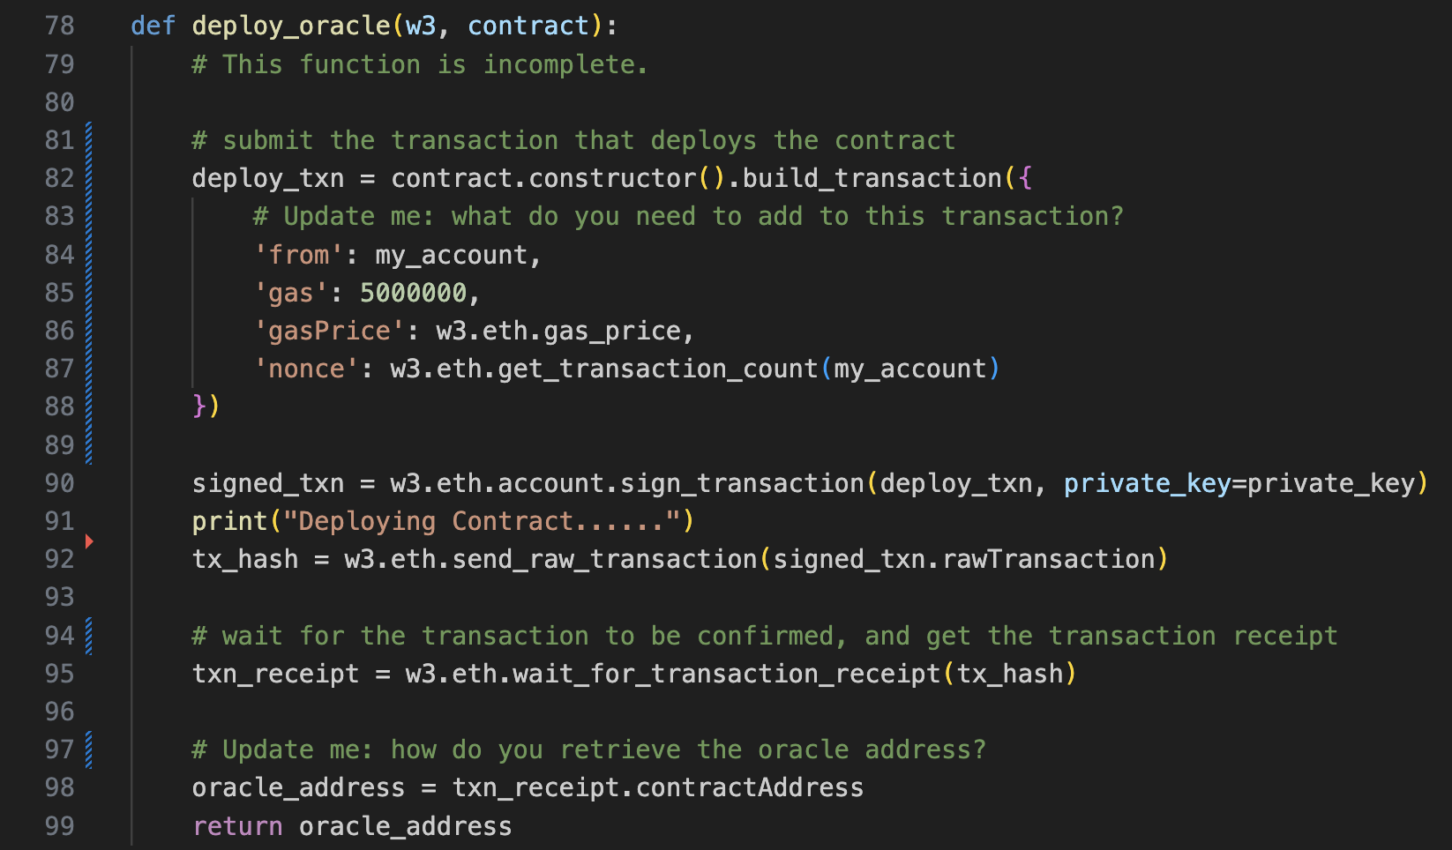

The image below showed that my Smart Contract has been copiled after running `**python oracle-node.py**`, and deployed to Sepolia test network using my own credentials.

The address of this smart: <https://sepolia.etherscan.io/address/0xc7b1f1023cdaf9f7b36e76a526810c765ca873a4>

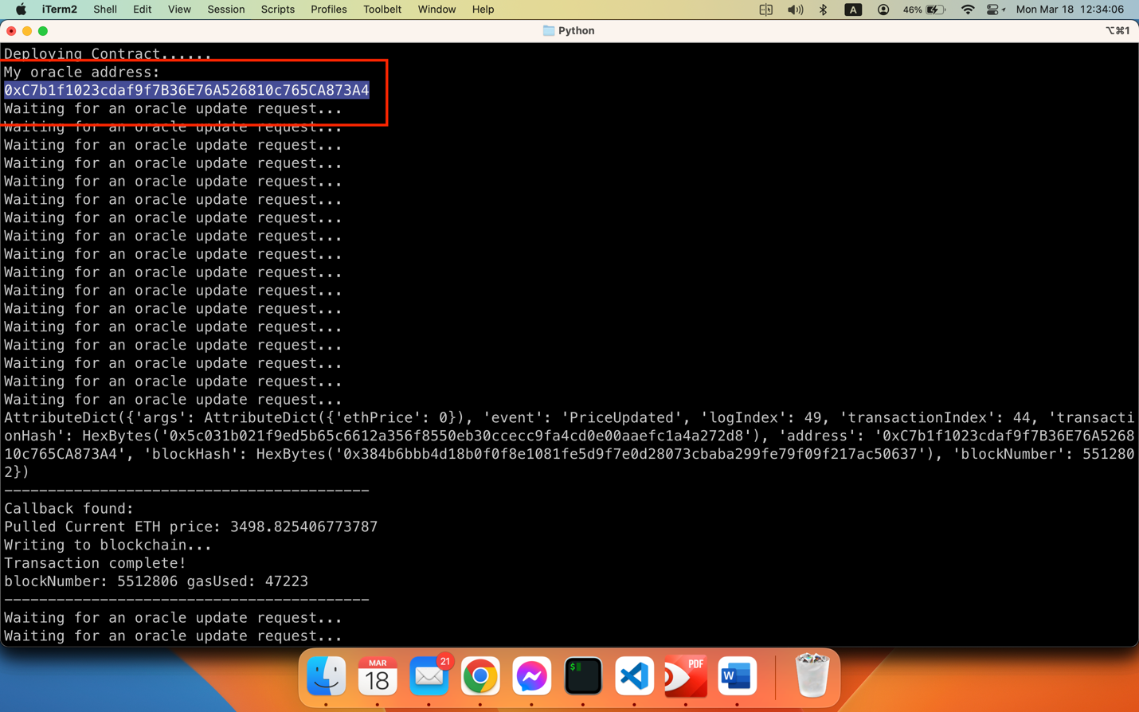

Figure : Smart Contract compiled & deployed

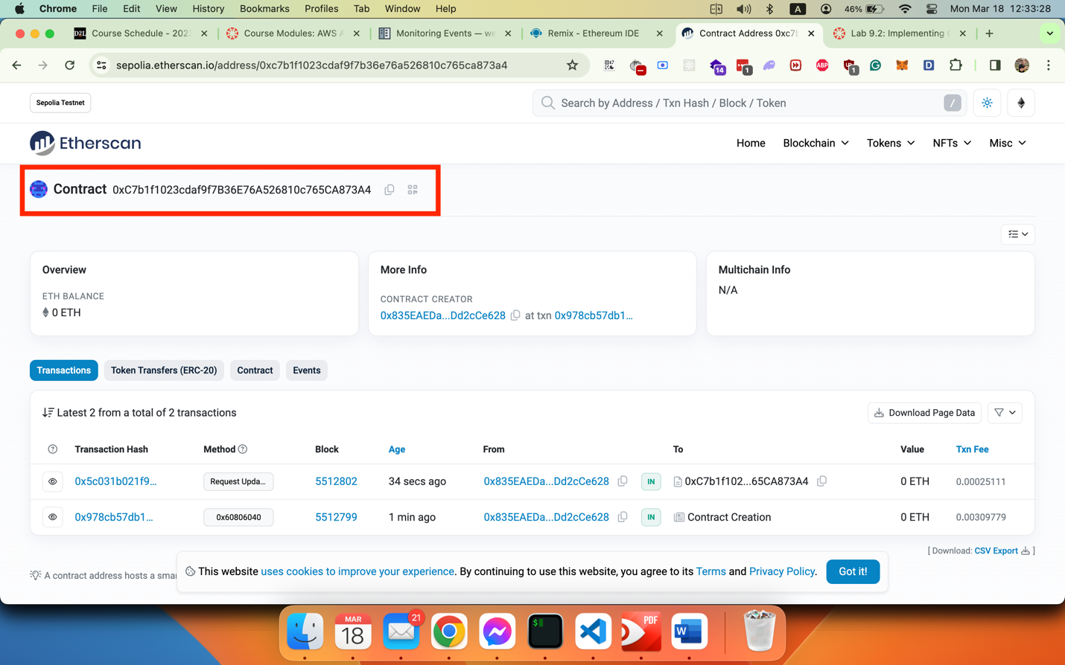

Figure : Smart contract information on Sepolia Test Network

1. **Oracle pulled new ETH price in USD and written it to the blockchain**

The code in file **oracle-node.py** from line 27-51 is using to getting price of ETH in USD via CoinMarketcap API.

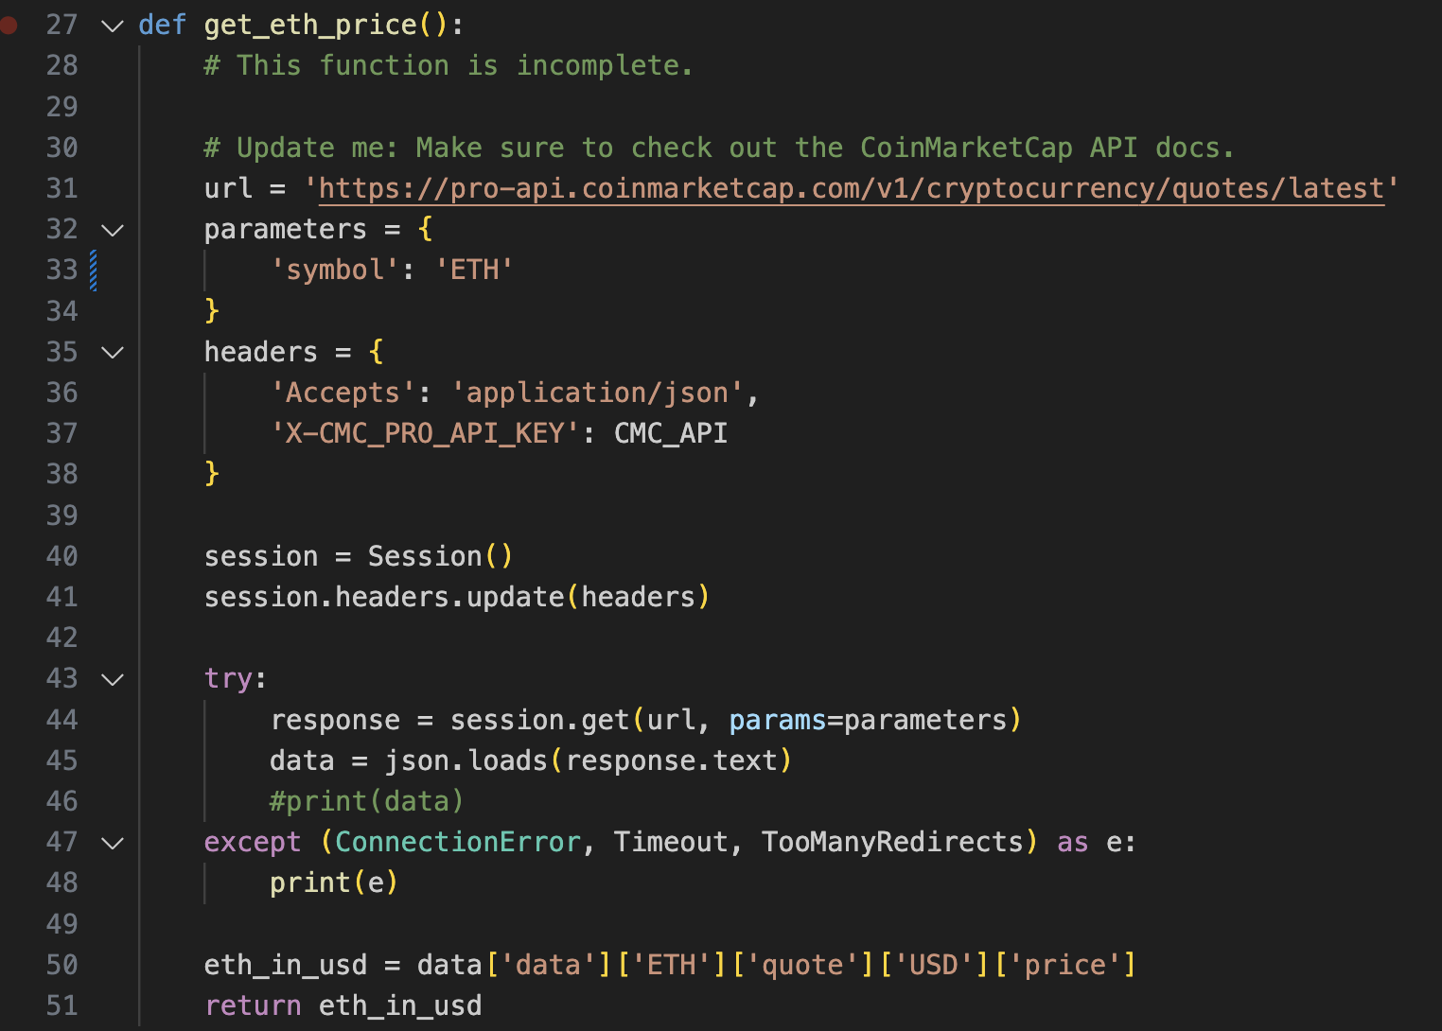

Line **102-120** is using to write it to the blockchain.

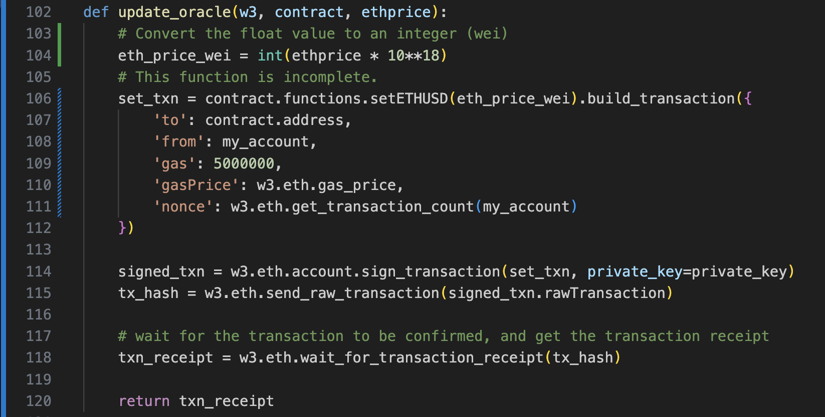

The image below showed that my function is working to receive the event on blockchain:

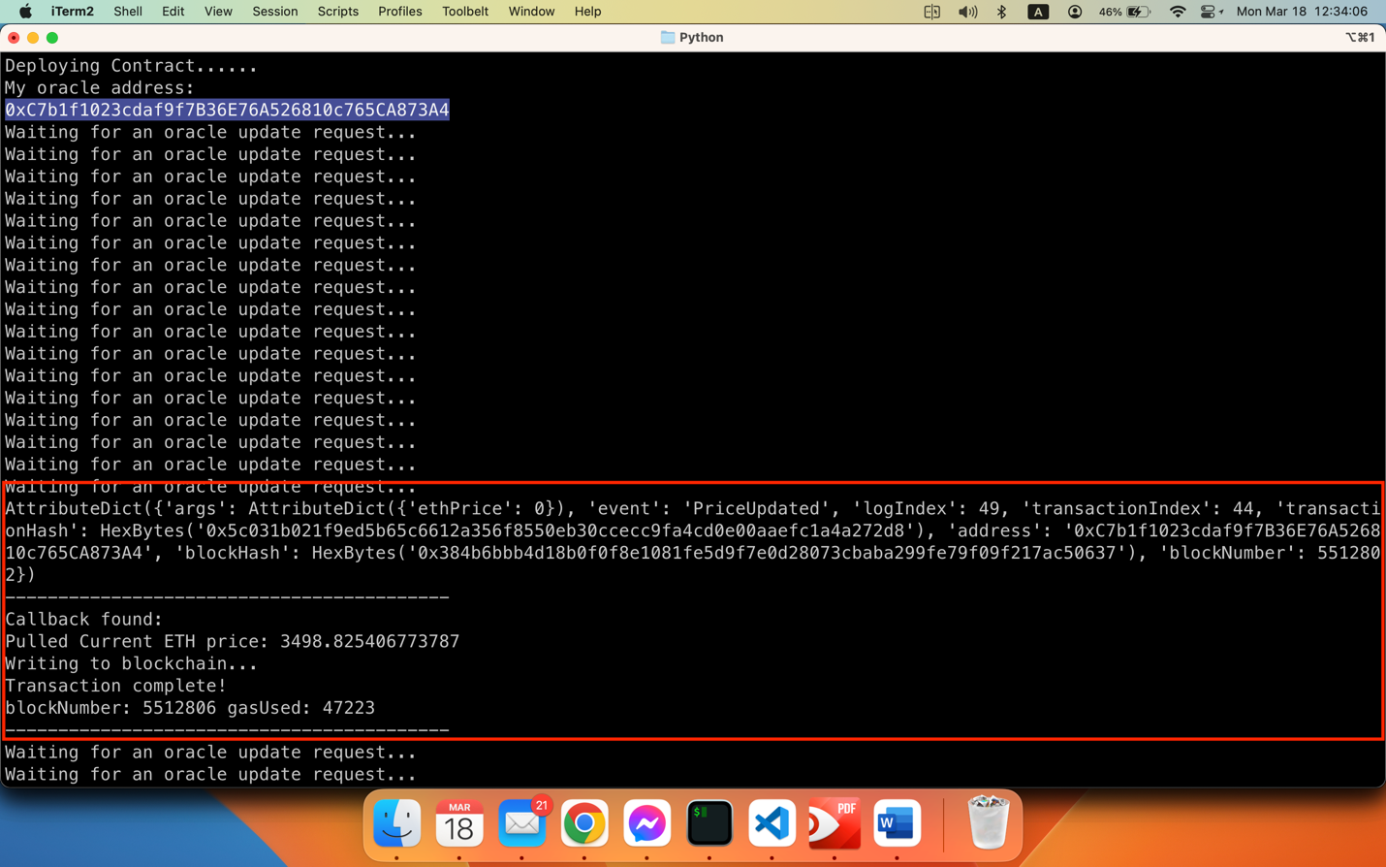

The images below are evidence of the **requestUpdate** requested:

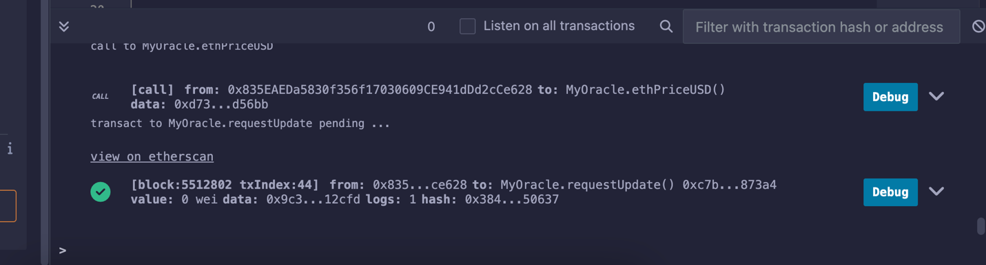

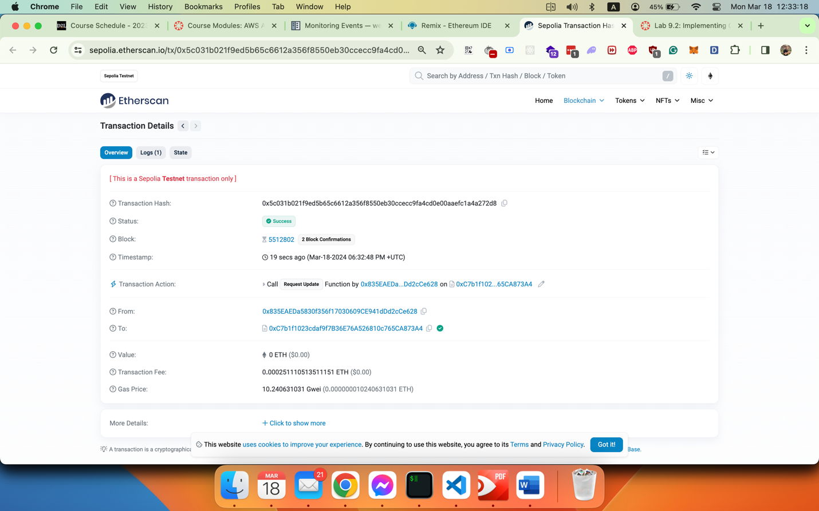

1. **ETH Price in USD using the state variable**

The image below shows that the price in USD using state variable which invoked after the Smart Contract compiled, deployed, and updated the price:

